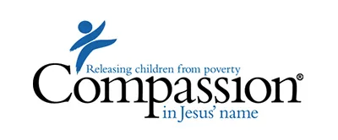

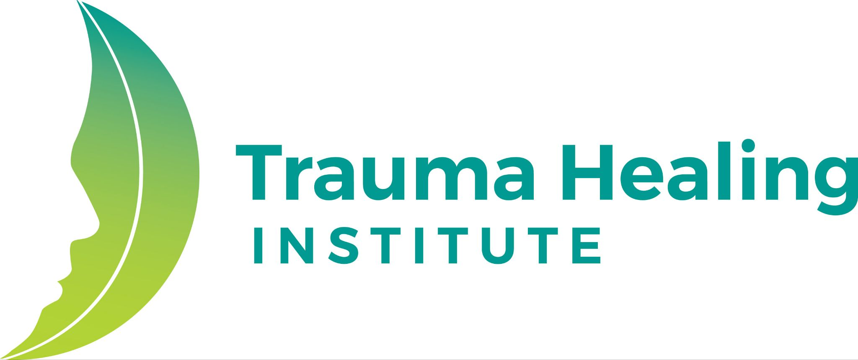

Pilot Instructions for Rise Up

Hello!

Thank you for your willingness to join us in this pilot of Rise Up: Building Strength and Resilience Together. Over the last two years, the Trauma Healing Institute at the American Bible Society, in collaboration with Compassion International, has created an app-based youth small group program experience focusing on emotional well-being. This pilot is designed to test the Rise Up program content, training model, and use of the app. Your feedback as a leader, as well as gathering feedback from youth participants, is vital to shaping the final version of the app and its programming.

Steps for Piloting:
Follow these steps to launch and complete your small group pilot successfully:

1. Download the App & Create an Account
- If you haven’t already, download the THI Audio App from the App Store or Google Play.

Apple/iOS users Android/Google Play users

- Create your personal account to access the Rise Up group leader training. You will get access to the Rise Up program after you pass the group leader training.
  - It is very important that if you are a current TH facilitator and have a THI Facilitator Website account, you sign in using the same email address and password you use to access the THI Facilitator Website.
  - If you are not a current TH Facilitator or do not have a THI Facilitator Website account, please sign up using whatever email you prefer. Note: you must be able to receive emails on your device at that address.
2. Take the Rise Up Group Leader Training
- Once you are successfully signed into the app, follow the prompts on your screen to take the Rise Up Group Leader Training.
- This training consists of seven modules, and at the end of modules 2-6, you will demonstrate your understanding of the content by completing a quiz.
- The training requires 2.5 hours of your time. Upon starting the training, you have 3 days to complete it. Otherwise, your training will be reset, and you will have to start from the beginning.
- If you do not pass, you can retake the training after 24 hours.

3. Identify a Co-Leader
- Select a trained co-leader to assist in leading the group.
- If your co-leader has not taken the Rise Up leader training, they must do that first before they assist you with the group.

4. Invite Youth Participants
- Select a group of 4–15 participants aged 13 or older.
- Get authorization from the parents or caregivers for their youth to participate, as well as the relevant leaders if you are implementing this program in your church or organization.
- Personally invite them (face-to-face, via text, on their preferred social media platform, or by phone) to join your small group.
  - Start with the youth you already know and have a relationship with.
  - Keep the details of the group simple.
  - Highlight what’s in it for them (why do they want to come).
  - Empower them to invite their friends.
  - Encourage them to join all 8 sessions.
- Consider the age and gender of your participants (for example, you may want to keep 13- and 14-year-olds together and 17- and 18-year-olds together).
- These groups will be held in person.
- Do not allow new participants to join after the first session, as group agreements have been established. This helps ensure safety and trust amongst all group members from the first session.

5. Prepare for your Rise Up Group
- Decide how often and how long your group will meet (e.g., weekly for 6 weeks). There are 8 sessions, each varying in duration from 45 to 90 minutes, totaling 10 hours. Please account for extra time on the first and last session for the youth to fill out surveys.
- Communicate the schedule clearly to participants. You can find a sample here.
- Access the Rise Up Leader Guide via the login portion of THI Website at https://traumahealinginstitute.org/. This guide provides helpful information to consider as you prepare for your Rise Up Group.
- Create a group within the app using the demo mode feature so you can listen to all the lessons before the group starts. This will help you become a more effective group leader if you’re aware of the content ahead of time.

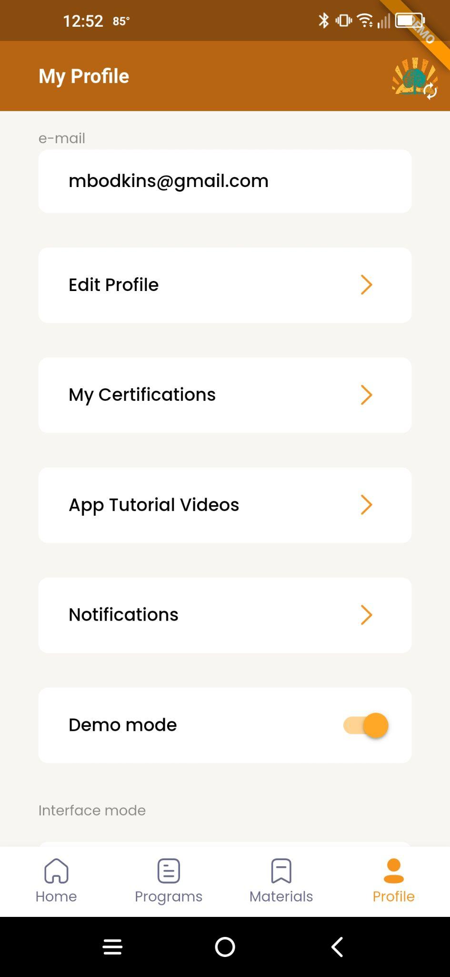
- To access the Demo mode, go to Profile and turn on Demo mode. You will know you are in demo mode as you will see a ribbon in the top right-hand corner that says Demo.
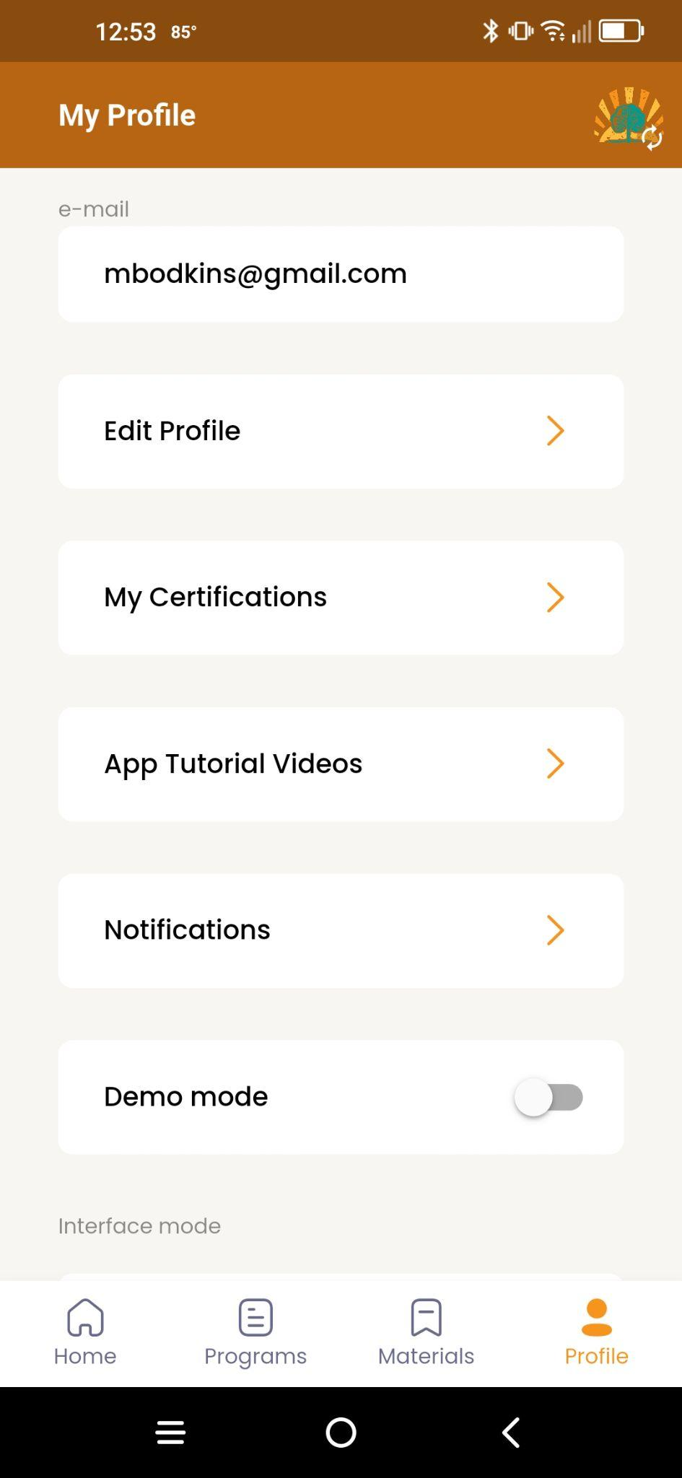

Demo Mode ON Demo Mode OFF

6. Start your Group & Complete Youth Pre-Survey
- Either prior to or on the day of, you will want to create your first group in the app.
  - Use the Create New Group Button
  - Choose Rise Up English
  - Choose a date, location, organization, # of participants, group name, color, and icon, and when all the information is entered, the “Create Group” button will show up
- Please make sure your app is OFF of demo mode, otherwise, the group will not be reported to the Trauma Healing Institute. Look at the top of your screen and make sure you do not see the word Demo.
- In your first session, reserve the first 30 minutes for the youth to complete the Pre-Survey. This survey is essential for evaluating program impact. You want to be available in case they have questions. Make sure they DO NOT put their name on the survey. For ABS partners, instead, you will use a number and country code system for identification.
  - For example, if the pilot is occurring in Ghana and there are 8 participants, the surveys will be 01-GH, 02-GH, 03-GH, and for on until you get to 8.
  - If the pilot is in the US, please add the organization at the end. For example, if ABS was running the pilot, the surveys would be 01-US-ABS, 02-US, ABS, etc.
  - As the leader, you will want to keep a list of the code assigned to the youth to ensure you use the same code during the post-survey. For example, if you assign 02-GH to Paul for the pre-survey, make sure Paul is assigned 02-GH for the post-survey.
  - When the surveys are complete, for ABS pilot partners, surveys will be scanned and uploaded to this folder. Choose the folder that is correct for your location. Once inside the folder, choose the Pre Survey Folder and upload the surveys. For Compassion partners, you will follow the instructions given by the Compassion team.

7. Run Your Sessions
- Use the app to guide the 8 sessions.
- Encourage engagement with content between meetings by giving youth the Rise Up Journal.
- Total time for the 8 sessions is about 10 hours; this does not account for the time it takes for surveys or preparation for the group.

8. Post-Survey
- At the end of your final session, reserve time for the youth to complete the Post-Survey. It will take approximately 30-45 minutes for the youth to complete the survey.
- You will follow the same numbering system as the pre-survey. If you had a youth drop out, and they were assigned 06-GH, you would just leave this number out then, since the youth did not return.
- If you are an ABS pilot partner, scan in the surveys, choose the folder that is correct for your location. Once inside the folder, choose the Post Survey folder, and upload the surveys. If you are a Compassion partner, you will follow the instructions given by the Compassion team.

9. Report Your Group
- Use the built-in reporting feature in the app to officially log your group and participation.
  - At the bottom of the screen with the sessions, you will see a “Close and report group” button. It will ask you to confirm.
  - If you have not already, there is an opportunity to add a 2nd leader via email. Otherwise, fill out the details regarding the number of participants who finished and the end date.

10. Complete Leader Survey
- After your group concludes, complete the Leader Feedback Survey to share your experience and suggestions.
- Each trained leader should complete their own survey.
Approximate Time Commitment for Rise Up Pilot
Time Commitment
- Leaders complete asynchronous video training & quizzes on the app (2.5 hours)
- Leaders implement at least one (1) in-person Rise Up small group with 6-12 people in each group.
  - 13.5 hours (1:15-1:30 hrs each lesson, 8 lessons total) + prep to coordinate each group + time for surveys
Thank you! Your role in this pilot is shaping the future of our youth. We appreciate your time, honesty, and effort!

American Bible Society and Compassion International

